**1.Team Members (2 people):**

1. Tejamanikanta Gudla (Team Coordinator)
2. Sai Teja Maredupalli Prasad

**2.Title of the Project:**

**“Book Store Management System”**

**3.Project Description:**

The Dataset contains 13 tables and those include the data of the Books, Authors, Information, Awards, Editions, Checkouts, Publishers, Ratings, Series and Sales for each quarter Q1, Q2, Q3 and Q4 having with primary keys for each table. This Dataset will help the books and to differentiate them by editions and series. It has a user view to view the books by Book ID and those are different for different editions as we have BookID1 and BookID2 and their concatenation is Main BookID which is in Information table.

Book: BookID, Title, AuthID

Author: AuthID, First Name, Last Name, Birthday, Country of Residence, Hrs Writing per Day

Info: BookID1,BookID2,GenreSeriesID,Volume Number,Staff Comment

Award: Title, Award Name, Year Won

Edition: ISBN, BookID, Format, PubID, Publication Date, Pages, Print Run Size (k), Price

Check outs: BookID, CheckoutMonth, Number of Checkouts

Publisher: PubID, Publishing House, City, State, Country, Year Established, Marketing Spend

Ratings:BookID, Rating, ReviewerID

Series: SeriesID, Series Name, Planned Volumes, Book Tour Events

Sales Q1: Sale Date, ISBN, Discount, ItemID, OrderID

Sales Q2: Sale Date, ISBN, Discount, ItemID, OrderID

Sales Q3: Sale Date, ISBN, Discount, ItemID, OrderID

Sales Q4: Sale Date, ISBN, Discount, ItemID, OrderID

**4.Specific users’ requirements that the system will be able to address.**

Users can find a book and its details using this database.

We can see what book had Series of book.

Users can see editions of each book.

Prices of the books

And sales based on which quarter, and we have Q1, Q2, Q3 and Q4.

**5.Business Rules**

* one book can have multiple authors, but each author can only write one book.
* one book can have multiple editions, but each edition belongs to only one book.
* one book can be checked out multiple times, but each checkout is for only one book.
* one book can have multiple ratings, but each rating is for only one book.
* one author can have only one info record, and each info record belongs to only one author.
* one info record can have only one series, and each series belongs to only one info record.
* one info record can have only one book, and each book belongs to only one info record.
* one book can win multiple awards, and each award can be won by multiple books.
* multiple books can have the same publisher, but each book can have only one publisher.
* one publisher can publish multiple editions, but each edition is published by only one publisher.
* one publisher can make multiple sales, but each sale is made by only one publisher.
* multiple sales can be made for the same edition, but each sale is for only one edition.
* multiple sales can include the same item, but each item is sold in only one sale.
* multiple sales can belong to the same order, but each sale is for only one order.
* one book can belong to multiple genre series, and each genre series can have multiple books.

**6. Entity-Relationship Diagram (ERD)**

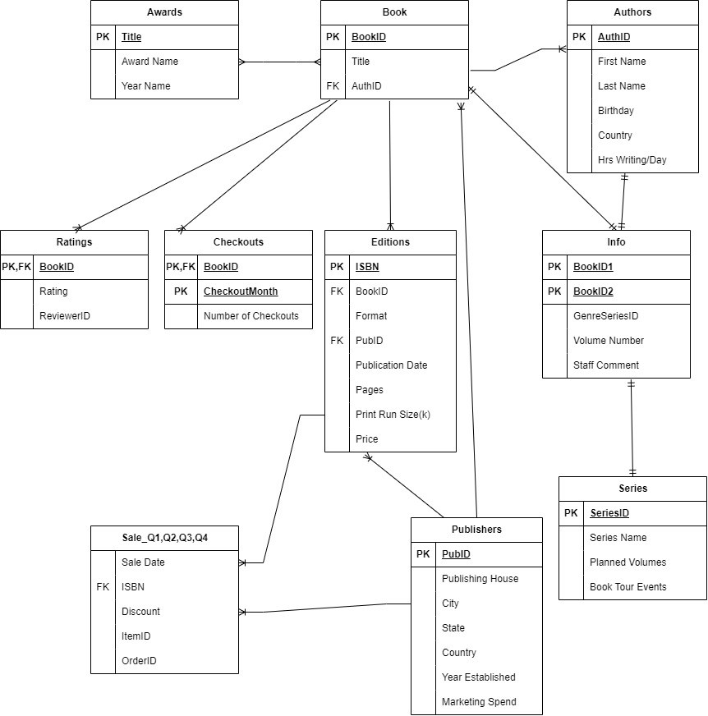

**7. Data Dictionary**

